****

**Applies to Version 3.11**

**DICOM 3.0 Conformance Statement**

# Conformance Statement Overview

|  |  |  |
| --- | --- | --- |
| Table 1.1  Network Services | | |
| SOP Classes | User of Service (SCU) | Provider of Service (SCP) |
| **Query and Retrieve** |  |  |
| Study Root Query/Retrieve Information Model—Find | Yes | Yes |
| Study Root Query/Retrieve Information Model—Move | Yes | Yes |
| **Transfer** |  |  |
| **(see note 1)** | Yes | Yes |

1. All conforming DICOM SOP classes for Composite IODs are supported in SCU and SCP roles. Includes SOPs listed in DICOM PS3.4:B.5-1 Standard SOP Classes, as well as private SOPs. Association acceptance is determined by configuration.

|  |  |  |
| --- | --- | --- |
| Table 1.2  Media Services | | |
| Media Storage Application Profile | Write Files (FSC) | Read Files (FSR) |
| **CD—Recordable** |  |  |
| General Purpose CD-R | See conformance note | Yes |
| General Purpose Secure CD-R | See conformance note | No |
| **DVD—Recordable** |  |  |
| General Purpose DVD-R | See conformance note | No |
| General Purpose Secure DVD-R | See conformance note | No |

1. Table of Contents

[1. Conformance Statement Overview 2](#_Toc715814481)

[3. Introduction 6](#_Toc545400427)

[3.1. Revision History 6](#_Toc1875960329)

[3.2. Audience 6](#_Toc1159477959)

[3.3. Remarks 6](#_Toc1991791414)

[3.3.1. Disclaimer 6](#_Toc377953437)

[3.3.2. Copyright Notice 7](#_Toc778526435)

[3.3.3. Trademark Acknowledgements 7](#_Toc3425806)

[3.3.4. Contact Address 7](#_Toc951730244)

[3.4. Definitions, Terms and Abbreviations 7](#_Toc1369336190)

[3.5. References 7](#_Toc1247565184)

[4. Implementation Model 8](#_Toc1756803347)

[4.1. Storage SCP AE 8](#_Toc617228452)

[4.1.1. Application Data Flow Diagram 8](#_Toc1616098053)

[4.1.2. Functional Definition of AE 8](#_Toc1959820128)

[4.1.3. Sequencing of Real World Activities 8](#_Toc280885227)

[4.2. Storage SCU AE 9](#_Toc2059706204)

[4.2.1. Application Data Flow Diagram 9](#_Toc235926698)

[4.2.2. Functional Definition of AE 9](#_Toc1617311143)

[4.2.3. Sequencing of Real World Activities 9](#_Toc544379387)

[4.3. DICOM DISC Writer AE 10](#_Toc301532037)

[4.3.1. Application Data Flow Diagram 10](#_Toc1060989900)

[4.3.2. Functional Definition of AE 10](#_Toc1136378268)

[4.3.3. Sequencing of Real World Activities 10](#_Toc52867047)

[4.4. Query and Retrieve SCU AE 11](#_Toc1853433403)

[4.4.1. Application Data Flow Diagram 11](#_Toc1700547753)

[4.4.2. Functional Definitions of AE 11](#_Toc796840461)

[4.4.3. Sequencing of Real World Activities 12](#_Toc1447821669)

[4.5. Query and Retrieve SCP AE 13](#_Toc179469664)

[4.5.1. Application Data Flow Diagram 13](#_Toc1224895004)

[4.5.2. Functional Definitions of AE 13](#_Toc1237060469)

[4.5.3. Sequencing of Real World Activities 14](#_Toc285288996)

[4.6. Importer AE 15](#_Toc137097089)

[4.6.1. Application Data Flow Diagram 15](#_Toc325050811)

[4.6.2. Functional Definitions of AE 15](#_Toc1642524812)

[4.6.3. Sequencing of Real World Activities 16](#_Toc2104432025)

[4.6.4. Application Data Flow Diagram 17](#_Toc1712752740)

[4.6.5. Functional Definitions of AE 17](#_Toc1017740249)

[4.6.6. Sequencing of Real World Activities 18](#_Toc1173341733)

[5. Service and Interoperability Description 20](#_Toc363787146)

[5.1. Storage SCP AE 20](#_Toc1645139902)

[5.1.1. SOP Classes 20](#_Toc1996778241)

[5.1.2. Association Establishment Policies 20](#_Toc1264892060)

[5.1.3. Association Initiation by Real World Activity 20](#_Toc1553605642)

[5.1.4. Association Acceptance Policy 20](#_Toc2018317509)

[5.2. Storage SCU AE 22](#_Toc1801182985)

[5.2.1. SOP Classes 22](#_Toc897169649)

[5.2.2. Association Establishment Policies 23](#_Toc174513430)

[5.2.3. Association Initiation by Real World Activity 23](#_Toc1810303067)

[5.2.4. Association Acceptance Policy 24](#_Toc1299759607)

[5.3. DICOM DISC Writer AE 25](#_Toc1148046343)

[5.3.2. File Meta Information 25](#_Toc1126181429)

[5.3.3. Real World Activity—Store Images on DICOM DISC 25](#_Toc25581809)

[5.4. Query and Retrieve SCU AE 27](#_Toc1949505834)

[5.4.1. SOP Classes 27](#_Toc388071994)

[5.4.2. Association Establishment Policies 27](#_Toc147420828)

[5.4.3. Association Initiation by Real World Activity 28](#_Toc2135831878)

[5.4.4. Sop Specific Conformance to C-Move SOP Class 30](#_Toc1505148792)

[5.4.5. Association Acceptance Policy 30](#_Toc1351499912)

[5.5. Query and Retrieve SCP AE 31](#_Toc335988816)

[5.5.1. SOP Classes 31](#_Toc1893526166)

[5.5.2. Association Establishment Policies 31](#_Toc781859665)

[5.5.3. Association Initiation by Real World Activity 31](#_Toc22317599)

[5.5.4. Association Acceptance for Real World Activity 31](#_Toc1225965636)

[5.6. Importer AE 35](#_Toc2122863192)

[5.6.2. Initiation by Real World Activity—Import Images 35](#_Toc897174940)

[5.7. Verification AE 36](#_Toc1704124782)

[5.7.1. SOP Classes 36](#_Toc1997700578)

[5.7.2. Association Establishment Policies 36](#_Toc1722406956)

[5.7.3. Association Initiation by Real World Activity 37](#_Toc531877809)

[5.7.4. Association Acceptance for Real World Activity—Accept Verification 37](#_Toc750684682)

[6. Network and Media Communication Details 39](#_Toc750582925)

[6.1. Supported Communication Stacks 39](#_Toc980763527)

[6.2. TCP/IP Stack 39](#_Toc431836476)

[6.3. API 39](#_Toc2111600496)

[6.4. Physical Media Support 39](#_Toc1637765240)

[6.5. Support of Extended Character Sets 39](#_Toc1819223366)

[7. Configuration 39](#_Toc845070418)

[7.1. Configurable Parameters 39](#_Toc1200624425)

[7.1.1. Host Configuration 39](#_Toc506770162)

[7.1.2. DICOM Association for DIMSE-C services 40](#_Toc402307463)

[7.1.3. Storage SCP AE 40](#_Toc58093051)

[7.1.4. Query and Retrieve SCU AE 40](#_Toc785930643)

[7.1.5. Query and Retrieve SCP AE 40](#_Toc213182596)

[7.1.6. Peer Configuration 40](#_Toc1491737040)

[8. Security 40](#_Toc840006429)

[8.1. Security Profiles 40](#_Toc1487594288)

[8.2. Association Level Security 40](#_Toc2117366363)

[8.3. Application Level Security 40](#_Toc139033658)

# Introduction

This document describes the conformance of the Vertex Application Suite to the DICOM 3.0 Standard [DICOM].

## Revision History

|  |  |  |  |
| --- | --- | --- | --- |
| Revision | Author | Comments | Date |
| 1 | Cyrus Samari | Created | 9/18/2015 |
| 2 | Dion Barrier | Revised | 04/27/2020 |
| 3 | Dion Barrier | Revised | 11/01/2023 |

## Audience

This document is intended for the audience listed below. It is assumed that the reader has a working knowledge of the DICOM Standard.

The document structure was designed for easier access to relevant information for different user groups:

* Clinical Users, who want to get an overview of the implemented interoperability features of the system can see Section 4 Implementation Model
* Personnel involved in Sales can use Section 1 to assess the compatibility between different systems involved in a sales situation.
* Systems Integrators can use information in Section 6 during system installation and information from Section 5 Service and Interoperability Description for details regarding the implemented services.
* Field Service Engineers can use the details from Section 5 Service and Interoperability Description and from Section 6 Network and Media Communication Details for troubleshooting.
* Hospital IT staff focusing on security can use the details provided in Section 8 Security regarding implemented Security features.

## Remarks

### Disclaimer

The scope of this DICOM Conformance Statement is to facilitate integration between Vertex and other DICOM products. The Conformance Statement should be read and understood in conjunction with the DICOM Standard. DICOM by itself does not guarantee interoperability.

* The Conformance Statement does, however, facilitate a first-level comparison for interoperability between different applications supporting compatible DICOM functionality.
* This Conformance Statement should not replace validation with other DICOM equipment to ensure proper exchange of intended information. In fact, it is the user’s responsibility to perform the following activities:
  + The comparison of Conformance Statements from Vertex with other DICOM conformant equipment is the first step towards assessing interconnectivity and interoperability between those systems.
  + Test procedures should be defined and executed to validate the required level of interoperability with specific DICOM conformant equipment, as established by the healthcare facility.

### Copyright Notice

©2009-2025 Sorna Corporation. All rights reserved.

* No part of this document may be copied or reprinted, in whole or part, without written permission.
* The contents of this document are subject to change without notice or legal obligation.

### Trademark Acknowledgements

Sorna® and Vertex® are registered trademark of Sorna Corporation. Windows is a registered trademark of Microsoft Corporation in the United States and other countries. This document may include trademarks or registered trademarks of other companies.

### Contact Address

Sorna Corporation

4101 Nicols Road

Eagan, MN 55122

## Definitions, Terms and Abbreviations

|  |  |
| --- | --- |
| AE | Application Entity |
| ANSI | American National Standard Institute |
| DICOM | Digital Imaging and Communications in Medicine |
| FSR | File Set Reader |
| FSC | File Set Creator |
| IOD | Information Object Definition |
| ISO | International Organization for Standardization |
| NEMA | National Electrical Manufacturers Association |
| SCP | Service Class Provider |
| SCU | Service Class User |
| SOP | Service-Object Pair |
| TCP/IP | Transmission Control Protocol/Internet Protocol |
| UID | Unique Identifier |
| XML | eXtensible Markup Language |

## References

|  |  |
| --- | --- |
| [DICOM] | Digital Imaging and Communications in Medicine (DICOM), NEMA PS 3.1-3.22, 2023d |
|  |  |

# Implementation Model

## Storage SCP AE

### Application Data Flow Diagram

*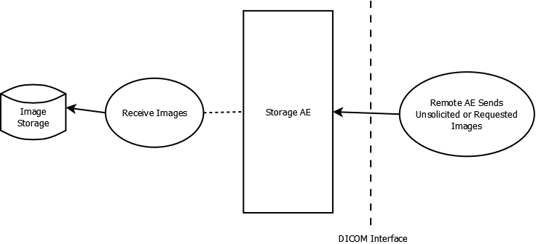*

Figure 4.1—Storage SCP AE Dataflow

### Functional Definition of AE

The Storage SCP AE accepts connections to the configured AE title’s presentation address. Associations having presentation contexts with Storage SOP classes will be accepted.

#### Receive Images

The Receive Images operation is initiated by a successful association with a remote AE requesting to store images. Images received from the remote AE are sent to an image storage system(s). The system(s) to which received images are sent are determined by configuration for the destination AE title.

### Sequencing of Real World Activities

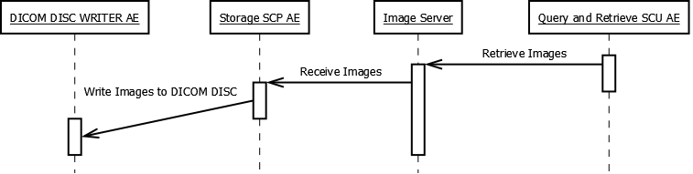

Figure 4.2—Example Real World Activity for Storage SCP AE

## Storage SCU AE

### Application Data Flow Diagram

*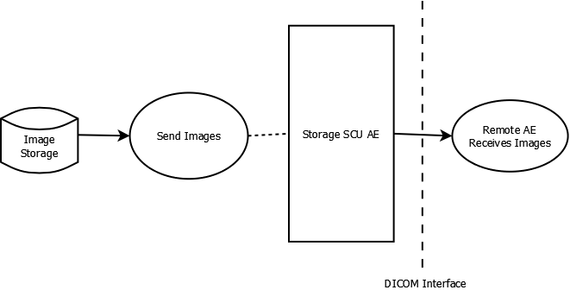*

Figure 4.3—Storage SCU AE Dataflow

### Functional Definition of AE

#### Send Images

The Send Images operation is initiated in response to Query and Retrieve or DICOM DISC media import operations. An association is initiated with the destination AE and is followed by a transfer of the requested images using C-Store operations.

### Sequencing of Real World Activities

Not Applicable

## DICOM DISC Writer AE

### Application Data Flow Diagram

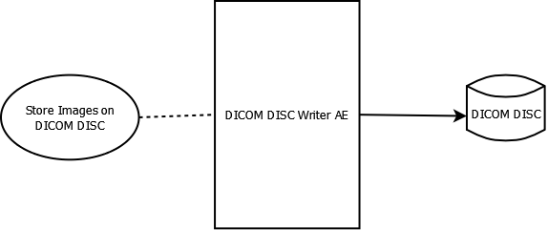

Figure 4.4—DICOM DISC Writer AE Dataflow

### Functional Definition of AE

#### Store Images on DICOM DISC

The operation Store Images on DICOM DISC is initiated by the existence of a job production order in the build queue. Images bundled with the job will be conveyed to a DICOM DISC. Job production orders may include the following options:

* **Data Encryption**—writes images in Secure DICOM File Format.
* **Re-identification**—modifies patient demographic information.
* **DISC Write Verification**—verifies successful creation of DISC media.
* **Include Structured Reports**—retrieves associated structured reports from image source.

### Sequencing of Real World Activities

Not applicable

## Query and Retrieve SCU AE

### Application Data Flow Diagram

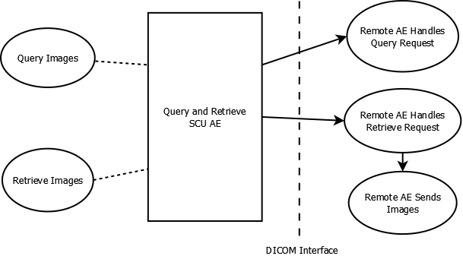

Figure 4.5—Query and Retrieve SCU AE Dataflow

### Functional Definitions of AE

#### Query Images

Query Images establishes an association with a DICOM Query/Retrieve SCP using a presentation context having a Find SOP class. A Find request is sent with user specified query fields.

#### Retrieve Images

Retrieve Images establishes an association with a DICOM Query/Retrieve SCP using a presentation context having a Move SOP class. A Move request is sent for selected studies.

### Sequencing of Real World Activities

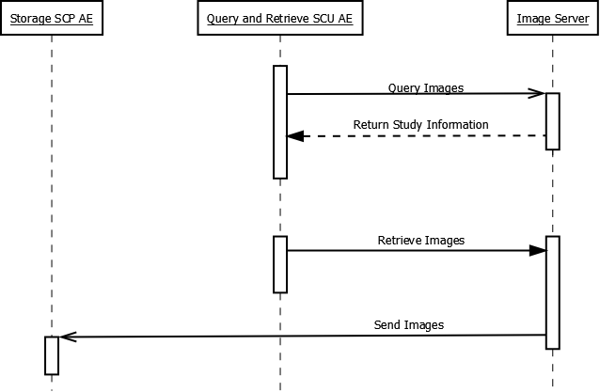

Figure 4.6—Example Real World Activity for Query and Retrieve SCU AE

## Query and Retrieve SCP AE

### Application Data Flow Diagram

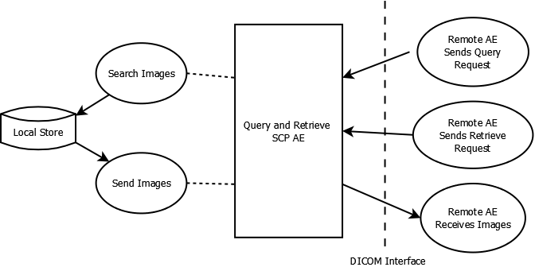

Figure 4.7—Query and Retrieve SCP AE Dataflow

### Functional Definitions of AE

The Query and Retrieve SCP AE accepts connections to the configured AE title’s presentation address. Associations having presentation contexts with Find or Move SOP classes will be accepted.

#### Search Images

Search Images is initiated by a Find request to the addressed local store. Search Images searches the host file system area assigned to the addressed local store for matches to user provided search criterion. Results are returned to the calling SCU.

#### Send Images

Send Objects is initiated by a Move request to the addressed local store. Send Images initiates Store requests through the Storage SCU AE for the image instances corresponding to the received Move request.

### Sequencing of Real World Activities

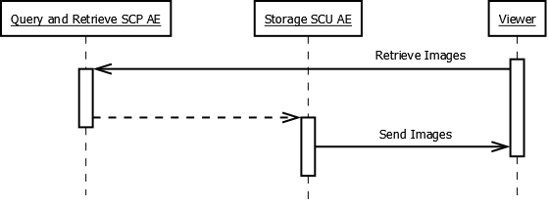

Figure 4.8—Example Real World Activity for Storage SCU AE

## Importer AE

### Application Data Flow Diagram

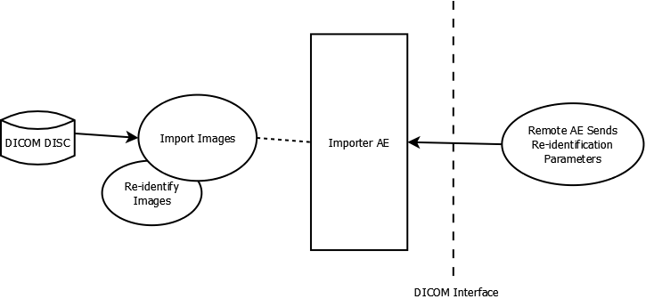

Figure 4.9—Importer AE Dataflow

### Functional Definitions of AE

The Importer AE is a FSR enabling the importation of DICOM part 10 files from removable DICOM disc media.

#### Import Images

Import Images reads in a DICOM file set and sends Store requests to a user selected Storage. Import Images includes the ability to re-identify patient demographic using one of the following user selected source options:

* **Query and Retrieve SCP**
* **Modality Worklist Management SCP**
* **User-entered Values**

### Sequencing of Real World Activities

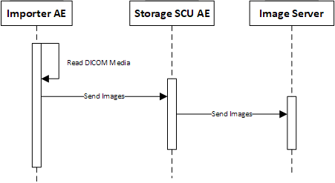

Figure 4.10—Example Real World Activity for Importer AE

Verification AE

### Application Data Flow Diagram

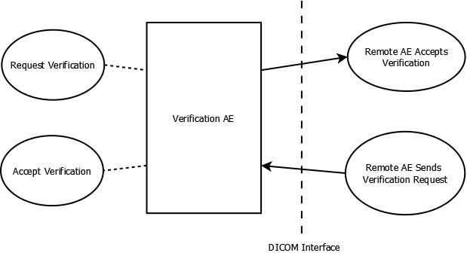

Figure 4.11—Verification AE Dataflow

### Functional Definitions of AE

#### Request Verification

The Verification AE acts as an SCU by sending requests with a presentation context having a Verification SOP class.

#### Accept Verification

The Verification AE acts as an SCP by accepting connections for associations having presentation contexts for Verification SOP classes.

### Sequencing of Real World Activities

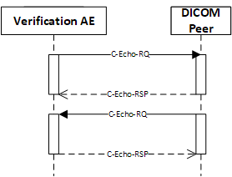

Figure .—Example Real World Activity for Verification AE

# Service and Interoperability Description

## Storage SCP AE

### SOP Classes

The Storage SCP AE provides Standard Conformance to the following SOP classes:

|  |  |  |  |
| --- | --- | --- | --- |
| Table 5.1  Supported SOP Classes | | | |
| SOP Class Name | SOP Class UID | SCU | SCP |
| (see note 1) | (see note 1) | NO | Yes |

1. All conforming DICOM SOP classes for Composite IODs are supported in SCU and SCP roles. Includes SOPs listed in DICOM PS3.4:B.5-1 Standard SOP Classes, as well as private SOPs. Association acceptance is determined by configuration.

### Association Establishment Policies

#### General

The DICOM standard Application context shall be specified.

|  |  |
| --- | --- |
| Application Context Name | 1.2.840.10008.3.1.1.1 |

#### Number of Associations

The Storage SCP AE is internally limited by configuration in the number of simultaneous associations it may accept.

|  |  |
| --- | --- |
| Maximum Number of Simultaneous Associations (acceptor) | 100 (default) |

#### Asynchronous Nature

Multiple outstanding operations over a single association are not supported.

|  |  |
| --- | --- |
| Maximum Number of Outstanding Asynchronous Transactions | 1 |

#### Implementation Identifying Information

|  |  |
| --- | --- |
| Implementation Class UID | 2.16.840.1.114444 |
| Implementation Version Name | VERTEX{x}[[1]](#footnote-1) |

### Association Initiation by Real World Activity

The Storage SCP AE never initiates an association.

### Association Acceptance Policy

The Storage SCP AE accepts associations from remote AEs offering valid Presentation Contexts.

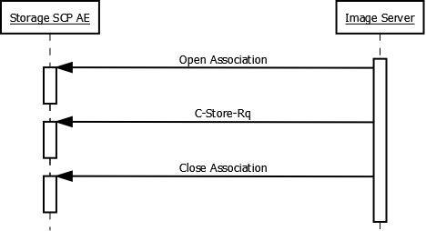

Figure .—Receive Images Activity

#### Accepted Presentation Contexts

Note: transfer syntax support is consistent across Storage classes.

|  |  |  |  |  |  |
| --- | --- | --- | --- | --- | --- |
| Table 5.2  Accepted Presentation Contexts | | | | | |
| **Abstract Syntax** | | **Transfer Syntax** | | **Role** | **Ext. Neg.** |
| **Name** | **UID** | **Name** | **UID** |
| See Table 5.1 | See Table 5.1 | Implicit VR Little Endian | 1.2.840.10008.1.2 | SCP | None |
| Explicit VR Little Endian | 1.2.840.10008.1.2.1 | SCP | None |
| Explicit VR Big Endian | 1.2.840.10008.1.2.2 | SCP | None |
| JPEG Process 1 Baseline | 1.2.840.10008.1.2.4.50 | SCP | None |
| JPEG Process Ext 24 | 1.2.840.10008.1.2.4.51 | SCP | None |
| JPEG Process 14 Lossless | 1.2.840.10008.1.2.4.57 | SCP | None |
| JPEG Process 14 Lossless SV1 | 1.2.840.10008.1.2.4.70 | SCP | None |
| JPEG Lossless | 1.2.840.10008.1.2.4.80 | SCP | None |
| JPEG Near Lossless | 1.2.840.10008.1.2.4.81 | SCP | None |
| JPEG 2000 Near Lossless | 1.2.840.10008.1.2.4.90 | SCP | None |
| JPEG 2000 | 1.2.840.10008.1.2.4.91 | SCP | None |
| MPEG 2 | 1.2.840.10008.1.2.4.100 | SCP | None |
| MPEG 4 High Profile | 1.2.840.10008.1.2.4.102 | SCP | None |

|  |  |  |  |
| --- | --- | --- | --- |
| Table 5.3  Storage SCP AE C-Store Status Return Reasons | | | |
| Service Status | Further Meaning | Error Code | Reason |
| Refused | Out of resources | A700 | Out of resources |
| Failed | Identifier Mismatch | A900 | Identifier/SOP Class mismatch |
|  | Not Supported | C001 | Option is not supported on the Vertex system |
|  | Volume Not Found | C002 | Unable to find specified local store |
|  | Not Responding | C003 | The server is not responding. Try again later |
|  | Not Authorized | C004 | The system could not log you on |
|  | Presentation Context Missing | C006 | Cannot understand |
| Cancel | Request Cancelled | FE00 | Cancelled |
| Pending | Pending | FF00 | Pending |
| Success | Success | 0000 | Success |

## Storage SCU AE

### SOP Classes

The Storage SCU AE provides Standard Conformance to the following SOP classes:

|  |  |  |  |
| --- | --- | --- | --- |
| Table 5.4  Supported SOP Classes | | | |
| SOP Class Name | SOP Class UID | SCU | SCP |
| (see note 1) | (see note 1) | Yes | No |

1. All conforming DICOM SOP classes for Composite IODs are supported in SCU and SCP roles. Includes SOPs listed in DICOM PS3.4:B.5-1 Standard SOP Classes, as well as private SOPs. Association acceptance is determined by configuration.

### Association Establishment Policies

#### General

The DICOM standard Application context shall be specified.

|  |  |
| --- | --- |
| Application Context Name | 1.2.840.10008.3.1.1.1 |

#### Number of Associations

The Storage SCU AE is not internally limited in the number of simultaneous associations it may initiate.

|  |  |
| --- | --- |
| Maximum Number of Simultaneous Associations (initiator) | No Limit |

#### Asynchronous Nature

Multiple outstanding operations over a single association are not supported.

|  |  |
| --- | --- |
| Maximum Number of Outstanding Asynchronous Transactions | 1 |

#### Implementation Identifying Information

|  |  |
| --- | --- |
| Implementation Class UID | 2.16.840.1.114444 |
| Implementation Version Name | VERTEX{x}[[2]](#footnote-2) |

### Association Initiation by Real World Activity

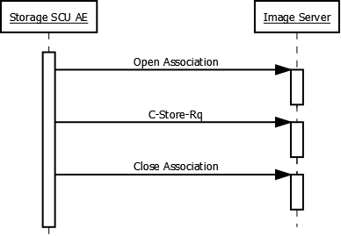

Figure 5.2—Send Images Activity

|  |  |  |  |  |  |
| --- | --- | --- | --- | --- | --- |
| Table 5.5  Proposed Presentation Contexts | | | | | |
| **Abstract Syntax** | | **Transfer Syntax** | | **Role** | **Ext. Neg.** |
| **Name** | **UID** | **Name** | **UID** |
| See Table 5.4 | See Table 5.4 | Implicit VR Little Endian | 1.2.840.10008.1.2 | SCU | None |
| Explicit VR Little Endian | 1.2.840.10008.1.2.1 | SCU | None |
| Explicit VR Big Endian | 1.2.840.10008.1.2.2 | SCU | None |
| JPEG Process 1 Baseline | 1.2.840.10008.1.2.4.50 | SCU | None |
| JPEG Process Ext 24 | 1.2.840.10008.1.2.4.51 | SCU | None |
| JPEG Process 14 Lossless | 1.2.840.10008.1.2.4.57 | SCU | None |
| JPEG Process 14 Lossless SV1 | 1.2.840.10008.1.2.4.70 | SCU | None |
| JPEG Lossless | 1.2.840.10008.1.2.4.80 | SCU | None |
| JPEG Near Lossless | 1.2.840.10008.1.2.4.81 | SCU | None |
| JPEG 2000 Near Lossless | 1.2.840.10008.1.2.4.90 | SCU | None |
| JPEG 2000 | 1.2.840.10008.1.2.4.91 | SCU | None |
| MPEG 2 | 1.2.840.10008.1.2.4.100 | SCU | None |
| MPEG 4 High Profile | 1.2.840.10008.1.2.4.102 | SCU | None |

### Association Acceptance Policy

The Storage SCU AE never accepts an association.

## DICOM DISC Writer AE

#### Conformance to DICOM Interchange of the Media Storage Service

DICOM DISC Writer AE supports DICOM Interchange of the Media Storage Service. It provides standard conformance as a FSC as defined in part 10 of the DICOM standard.

NOTE: The DICOM DISC Writer AE is agnostic with respect to transfer syntax as an FSC for Image Storage classes. Image instances included in a build job production order receive no conversion/post-processing. Standard conformant application profiles are only possible if images to be written already match profile transfer syntax options.

|  |  |  |  |
| --- | --- | --- | --- |
| Table 5.6  Supported Application Profiles | | | |
| Application Profiles Supported | Real-World Activity | Roles | SC Option |
| STD-GEN-CD | Store Images on DICOM DISC | FSC | Interchange |
| STD-GEN-SEC-CD | Store Images on DICOM DISC | FSC | Interchange |
| STD-GEN-DVD | Store Images on DICOM DISC | FSC | Interchange |
| STD-GEN-SEC-DVD | Store Images on DICOM DISC | FSC | Interchange |

### File Meta Information

|  |  |
| --- | --- |
| Implementation Class UID | 2.16.840.1.114444 |
| Implementation Version Name | VERTEX{x}[[3]](#footnote-3) |

### Real World Activity—Store Images on DICOM DISC

The DICOM DISC Writer AE acts as an FSC to export SOP instances associated with DICOM DISC build jobs.

The user is able to provide DISC production options that include the re-identification of patient demographics, encryption of DICOM files[[4]](#footnote-4) as well as DISC verification.

#### Options

DICOM DISC Writer AE supports the SOP classes and Transfer Syntaxes listed in the table below.

|  |  |  |  |
| --- | --- | --- | --- |
| Table 5.7  Supported IODs, SOP Classes and Transfer Syntaxes | | | |
| IOD | SOP Class UID | Transfer Syntax | Transfer Syntax UID |
| Basic Directory | 1.2.840.10008.1.3.10 | Explicit VR Little Endian Uncompressed | 1.2.840.10008.1.2.1 |
| (see note 1) | (see note 1) | Implicit VR Little Endian | 1.2.840.10008.1.2 |
| Explicit VR Little Endian | 1.2.840.10008.1.2.1 |
| Explicit VR Big Endian | 1.2.840.10008.1.2.2 |
| JPEG Process 1 Baseline | 1.2.840.10008.1.2.4.50 |
| JPEG Process Ext 24 | 1.2.840.10008.1.2.4.51 |
| JPEG Process 14 Lossless | 1.2.840.10008.1.2.4.57 |
| JPEG Process 14 Lossless SV1 | 1.2.840.10008.1.2.4.70 |
| JPEG Lossless | 1.2.840.10008.1.2.4.80 |
| JPEG Near Lossless | 1.2.840.10008.1.2.4.81 |
| JPEG 2000 Near Lossless | 1.2.840.10008.1.2.4.90 |
| JPEG 2000 | 1.2.840.10008.1.2.4.91 |
| MPEG 2 | 1.2.840.10008.1.2.4.100 |
| MPEG 4 High Profile | 1.2.840.10008.1.2.4.102 |

1. All conforming DICOM SOP classes for Composite IODs are supported in SCU and SCP roles. Includes SOPs listed in DICOM PS3.4:B.5-1 Standard SOP Classes, as well as private SOPs. Association acceptance is determined by configuration.

## Query and Retrieve SCU AE

### SOP Classes

The Query and Retrieve SCU AE provides Standard Conformance to the following SOP classes:

|  |  |  |  |
| --- | --- | --- | --- |
| Table 5.8  Supported SOP Classes | | | |
| SOP Class Name | SOP Class UID | SCU | SCP |
| Study Root Query/Retrieve Information Model—Find | 1.2.840.10008.5.1.4.1.2.2.1 | Yes | No |
| Study Root Query/Retrieve Information Model—Move | 1.2.840.10008.5.1.4.1.2.2.2 | Yes | No |

### Association Establishment Policies

#### General

The DICOM standard Application context shall be specified.

|  |  |
| --- | --- |
| Application Context Name | 1.2.840.10008.3.1.1.1 |

#### Number of Associations

The Query and Retrieve SCU AE is not internally limited in the number of simultaneous associations it may initiate.

|  |  |
| --- | --- |
| Maximum Number of Simultaneous Associations (initiator) | No Limit |

#### Asynchronous Nature

Multiple outstanding operations over a single association are not supported.

|  |  |
| --- | --- |
| Maximum Number of Outstanding Asynchronous Transactions | 1 |

#### Implementation Identifying Information

|  |  |
| --- | --- |
| Implementation Class UID | 2.16.840.1.114444 |
| Implementation Version Name | VERTEX{x}[[5]](#footnote-5) |

### Association Initiation by Real World Activity

#### Real World Activity—Query Images

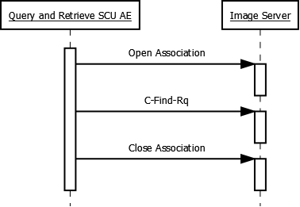

Figure 5.3—Query Images Activity

|  |  |  |  |  |  |
| --- | --- | --- | --- | --- | --- |
| Table 5.9  Proposed Presentation Contexts | | | | | |
| **Abstract Syntax** | | **Transfer Syntax** | | **Role** | **Ext. Neg.** |
| **Name** | **UID** | **Name** | **UID** |
| Study Root Query/Retrieve Information Model—Find | 1.840.10008.5.1.4.1.2.2.1 | Implicit VR Little Endian | 1.2.840.10008.1.2 | SCU | None |

#### SOP Specific Conformance to C-Find SOP Class

Query and Retrieve AE SCU provides standard conformance to the C-Find SOP class. Only a single information model, Study Root is supported.

|  |  |
| --- | --- |
| Table 5.10  Study Root Request Identifier for Query and Retrieve SCU AE | |
| Name | Tag |
| **Study Level** |  |
| Patient’s ID | (0010,0020) |
| Patient’s Name | (0010,0010) |
| Patient’s Sex | (0010,0040) |
| Study ID | (0020,0010) |
| Study Date | (0008,0020) |
| Study Accession No. | (0008,0050) |
| Study Description | (0008,1030) |
| Modalities In Study | (0008,0061) |
| **Series Level** |  |
| Series Instance UID | (0020,000E) |
| Modality | (0008,0060) |
| Series Description | (0008,103E) |
| Series Date | (0008,0021) |
| Series Number | (0020,0011) |

#### Real World Activity—Retrieve Images

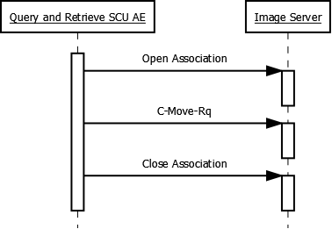

Figure .—Retrieve Images Activity

|  |  |  |  |  |  |
| --- | --- | --- | --- | --- | --- |
| Table 5.11  Proposed Presentation Contexts | | | | | |
| **Abstract Syntax** | | **Transfer Syntax** | | **Role** | **Ext. Neg.** |
| **Name** | **UID** | **Name** | **UID** |
| Study Root Query/Retrieve Information Model—Move | 1.840.10008.5.1.4.1.2.2.2 | Implicit VR Little Endian | 1.2.840.10008.1.2 | SCU | None |

### Sop Specific Conformance to C-Move SOP Class

Query and Retrieve AE SCU provides standard conformance to the C-Move SOP class.

### Association Acceptance Policy

The Query and Retrieve SCU AE does not accept associations.

## Query and Retrieve SCP AE

### SOP Classes

The Query and Retrieve SCP AE provides Standard Conformance to the following SOP classes:

|  |  |  |  |
| --- | --- | --- | --- |
| Table 5.12  Supported SOP Classes | | | |
| SOP Class Name | SOP Class UID | SCU | SCP |
| Study Root Query/Retrieve Information Model—Find | 1.2.840.10008.5.1.4.1.2.2.1 | No | Yes |
| Study Root Query/Retrieve Information Model—Move | 1.2.840.10008.5.1.4.1.2.2.2 | No | Yes |

### Association Establishment Policies

#### General

The DICOM standard Application context shall be specified.

|  |  |
| --- | --- |
| Application Context Name | 1.2.840.10008.3.1.1.1 |

#### Number of Associations

The Query and Retrieve SCP AE is internally limited by configuration in the number of simultaneous associations it may accept.

|  |  |
| --- | --- |
| Maximum Number of Simultaneous Associations (acceptor) | 100 (default) |

#### Asynchronous Nature

Multiple outstanding operations over a single association are not supported.

|  |  |
| --- | --- |
| Maximum Number of Outstanding Asynchronous Transactions | 1 |

#### Implementation Identifying Information

|  |  |
| --- | --- |
| Implementation Class UID | 2.16.840.1.114444 |
| Implementation Version Name | VERTEX{x}[[6]](#footnote-6) |

### Association Initiation by Real World Activity

The Query and Retrieve SCP AE never initiates an association.

### Association Acceptance for Real World Activity

The Query and Retrieve SCP AE accepts associations from remote AEs offering valid Presentation Contexts.

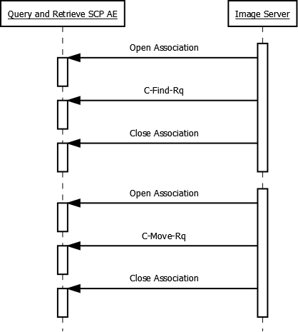

Figure .—Search Images and Send Images

#### Accepted Presentation Contexts

|  |  |  |  |  |  |  |  |
| --- | --- | --- | --- | --- | --- | --- | --- |
| Table 5.13  Accepted Presentation Contexts | | | | | | | |
| **Abstract Syntax** | | **Transfer Syntax** | | | | **Role** | **Ext. Neg.** |
| **Name** | **UID** | **Name** | | **UID** | |
| See Table 5.12 | See Table 5.12 | Implicit VR Little Endian | | 1.2.840.10008.1.2 | | SCP | None |
| Explicit VR Little Endian | | 1.2.840.10008.1.2.1 | | SCP | None |
| Explicit VR Big Endian | | 1.2.840.10008.1.2.2 | | SCP | None |
| JPEG Process 1 Baseline | | 1.2.840.10008.1.2.4.50 | | SCP | None |
| JPEG Process Ext 24 | | 1.2.840.10008.1.2.4.51 | | SCP | None |
| JPEG Process 14 Lossless | | 1.2.840.10008.1.2.4.57 | | SCP | None |
| JPEG Process 14 Lossless SV1 | | 1.2.840.10008.1.2.4.70 | | SCP | None |
| JPEG Lossless | | 1.2.840.10008.1.2.4.80 | | SCP | None |
| JPEG Near Lossless | | 1.2.840.10008.1.2.4.81 | | SCP | None |
| JPEG 2000 Near Lossless | | 1.2.840.10008.1.2.4.90 | | SCP | None |
| JPEG 2000 | | 1.2.840.10008.1.2.4.91 | | SCP | None |
| MPEG 2 | | 1.2.840.10008.1.2.4.100 | | SCP | None |
| MPEG 4 High Profile | | 1.2.840.10008.1.2.4.100 | | SCP | None |
| Table 5.14  Study Root Request Identifier for Query and Retrieve SCP AE | | | | | | | |
| Name | | | Tag | | Types of Matching | | |
| **Study Level** | | |  | |  | | |
| Patient’s ID | | | (0010,0020) | | S, U, W | | |
| Patient’s Name | | | (0010,0010) | | S, U, W | | |
| Patient’s DOB | | | (0010,0030) | | S, U | | |
| Patient’s Sex | | | (0010,0040) | | S, U | | |
| Study UID | | | (0020,000D) | | S, U | | |
| Study ID | | | (0020,0010) | | S, U | | |
| Study Date | | | (0008,0020) | | R, U | | |
| Study Accession No. | | | (0008,0050) | | S, U, W | | |
| Study Description | | | (0008,1030) | | S, U, W | | |
| **Legend:** R= Range; S = Single Value; U = Universal; W = Wild Card | | | | | | | |

NOTE: Wild card matching does not support the “OR” (‘\’) operator. Patient name matching does not support the “caret” (‘^’) operator.

|  |  |  |  |
| --- | --- | --- | --- |
| Table 5.15  Query and Retrieve SCP AE Status Return Reasons | | | |
| Service Status | Further Meaning | Error Code | Reason |
| Refused | Out of resources | A700 | Out of resources |
|  | Move Host Unknown | A801 | Unknown move destination |
| Failed | Identifier Mismatch | A900 | Identifier/SOP Class mismatch |
|  | Not Supported | C001 | Option is not supported on the Vertex system |
|  | Volume Not Found | C002 | Unable to find specified local store |
|  | Not Responding | C003 | The server is not responding. Try again later |
|  | Not Authorized | C004 | The system could not log you on |
|  | Data File Missing | C005 | File Not Found |
|  | Presentation Context Missing | C006 | Cannot understand |
| Cancel | Request Cancelled | FE00 | Cancelled |
| Pending | Pending | FF00 | Pending |
| Success | Success | 0000 | Success |

## Importer AE

#### Conformance to DICOM Interchange of the Media Storage Service

Importer AE supports DICOM Interchange of the Media Storage Service. It provides standard conformance as a FSR as defined part 10 of the DICOM standard.

NOTE: The Importer AE is agnostic with respect to transfer syntax as an FSR for Image Storage classes. Conversion/post-processing of images is delegated to the Storage SCU AE.

|  |  |  |  |
| --- | --- | --- | --- |
| Table 5.16  Supported Application Profiles | | | |
| Application Profiles Supported | Real-World Activity | Roles | SC Option |
| STD-GEN-CD | Store Images on DICOM DISC | FSR | Interchange |

### Initiation by Real World Activity—Import Images

The Importer AE acts as an FSR to import DICOM image instance files into the user specified remote AE.

#### Options

Importer AE supports the SOP classes and Transfer Syntaxes listed in the table below.

|  |  |  |  |
| --- | --- | --- | --- |
| Table 5.17  Supported IODs, SOP Classes and Transfer Syntaxes | | | |
| IOD | SOP Class UID | Transfer Syntax | Transfer Syntax UID |
| Basic Directory | 1.2.840.10008.1.3.10 | Explicit VR Little Endian Uncompressed | 1.2.840.10008.1.2.1 |
| (see note 1) | (see note 1) | Implicit VR Little Endian | 1.2.840.10008.1.2 |
| Explicit VR Little Endian | 1.2.840.10008.1.2.1 |
| Explicit VR Big Endian | 1.2.840.10008.1.2.2 |
| JPEG Process 1 Baseline | 1.2.840.10008.1.2.4.50 |
| JPEG Process Ext 24 | 1.2.840.10008.1.2.4.51 |
| JPEG Process 14 Lossless | 1.2.840.10008.1.2.4.57 |
| JPEG Process 14 Lossless SV1 | 1.2.840.10008.1.2.4.70 |
| JPEG Lossless | 1.2.840.10008.1.2.4.80 |
| JPEG Near Lossless | 1.2.840.10008.1.2.4.81 |
| JPEG 2000 Near Lossless | 1.2.840.10008.1.2.4.90 |
| JPEG 2000 | 1.2.840.10008.1.2.4.91 |
| MPEG 2 | 1.2.840.10008.1.2.4.100 |
| MPEG 4 High Profile | 1.2.840.10008.1.2.4.100 |

1. All conforming DICOM SOP classes for Composite IODs are supported in SCU and SCP roles. Includes SOPs listed in DICOM PS3.4:B.5-1 Standard SOP Classes, as well as private SOPs. Association acceptance is determined by configuration.

## Verification AE

### SOP Classes

The Verification AE provides Standard Conformance to the following SOP classes:

|  |  |  |  |
| --- | --- | --- | --- |
| Table 5.18  Supported SOP Classes | | | |
| SOP Class Name | SOP Class UID | SCU | SCP |
| Verification | 1.2.840.10008.1.1 | Yes | Yes |

### Association Establishment Policies

#### General

The DICOM standard Application context shall be specified.

|  |  |
| --- | --- |
| Application Context Name | 1.2.840.10008.3.1.1.1 |

#### Number of Associations

The Verification AE is not internally limited in the number of simultaneous associations it may initiate.

|  |  |
| --- | --- |
| Maximum Number of Simultaneous Associations (initiator) | No Limit |
| Maximum Number of Simultaneous Associations (acceptor) | 100 (default) |

#### Asynchronous Nature

Multiple outstanding operations over a single association are not supported.

|  |  |
| --- | --- |
| Maximum Number of Outstanding Asynchronous Transactions | 1 |

#### Implementation Identifying Information

|  |  |
| --- | --- |
| Implementation Class UID | 2.16.840.1.114444 |
| Implementation Version Name | VERTEX{x}[[7]](#footnote-7) |

### Association Initiation by Real World Activity

#### Activity—Request Verification

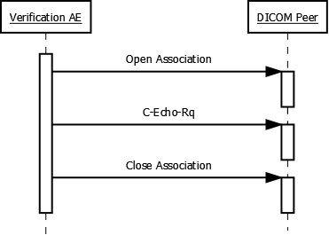

Figure 5.6—Request Verification Activity

|  |  |  |  |  |  |
| --- | --- | --- | --- | --- | --- |
| Table 5.19  Proposed Presentation Contexts | | | | | |
| **Abstract Syntax** | | **Transfer Syntax** | | **Role** | **Ext. Neg.** |
| **Name** | **UID** | **Name** | **UID** |
| Verification | 1.2.840.10008.1.1 | Implicit VR Little Endian | 1.2.840.10008.1.2 | SCU | None |

### Association Acceptance for Real World Activity—Accept Verification

The Verification AE accepts associations from remote AEs offering valid Presentation Contexts to fulfill the Accept Verification activity.

#### VerificationAE_SCP-SpecSeq.png

Figure 5.7—Accept Verification Activity

#### Accepted Presentation Contexts

|  |  |  |  |  |  |
| --- | --- | --- | --- | --- | --- |
| Table 5.20  Accepted Presentation Contexts | | | | | |
| **Abstract Syntax** | | **Transfer Syntax** | | **Role** | **Ext. Neg.** |
| **Name** | **UID** | **Name** | **UID** |
| Verification | 1.2.840.10008.1.1 | Implicit VR Little Endian | 1.2.840.10008.1.2 | SCP | None |
| Explicit VR Little Endian | 1.2.840.10008.1.2.1 | SCP | None |
| Explicit VR Big Endian | 1.2.840.10008.1.2.2 | SCP | None |

# Network and Media Communication Details

## Supported Communication Stacks

DICOM Upper Layer over TCP/IP as defined by part 8 of the DICOM standard is supported.

## TCP/IP Stack

The TCP/IP stack is inherited from the underlying host operating system.

## API

The application makes use of the Windows Socket 2 interface.

## Physical Media Support

Any physical medium supported by the host operating system can be used.

## Support of Extended Character Sets

The Vertex Application Suite supports the following character sets:

* ISO-IR 6 (default ASCII)
* ISO-IR 13 (Japanese Katakana)
* ISO-IR 87 (Japanese)
* ISO-IR 100 (ISO/IEC 8859-1 Latin 1)
* ISO-IR 101 (ISO/IEC 8859-2 Latin 2)
* ISO-IR 109 (ISO/IEC 8859-3 Latin 3)
* ISO-IR 110 (ISO/IEC 8859-4 Latin 4)
* ISO-IR 126 (ISO/IEC 8859-7 Greek)
* ISO-IR 127 (ISO/IEC 8859-6 Arabic)
* ISO-IR 138 (ISO/IEC 8859-8 Hebrew)
* ISO-IR 144 (ISO/IEC 8859-5 Cyrillic)
* ISO-IR 148 (ISO/IEC 8859-9 Turkish)
* ISO-IR 149 (Korean)
* ISO-IR 166 (Thai Windows)
* GB18030 (Chinese Simplified)
* Unicode

# Configuration

Configuration of the Vertex Application Suite may be accomplished through the Windows client or in some circumstances by editing the underlying documents.

## Configurable Parameters

### Host Configuration

* Port number
* Binding address
* Maximum PDU size
* Maximum concurrent accepted connections
* Send/Receive buffer size
* Receive timeout
* Socket linger
* Socket keep-alive

### DICOM Association for DIMSE-C services

* Accepted SOP classes

### Storage SCP AE

* AE Title
* Originator timeout

### Query and Retrieve SCU AE

* AE Title

### Query and Retrieve SCP AE

* AE Title

### Peer Configuration

* AE title
* IP address
* Port number

# Security

## Security Profiles

The DICOM DISC Writer AE provides standard conformance to the Basic DICOM Media Security Profile.

## Association Level Security

The Vertex local store is secured against an acceptable peer list.

## Application Level Security

Clients of the Vertex Application Suite are secured with password protected user accounts.

1. “{x}” representing the application version number. E.g. “2.7.0.6“ [↑](#footnote-ref-1)
2. “{x}” representing the application version number. E.g. “2.7.0.6“ [↑](#footnote-ref-2)
3. “{x}” representing the application version number. E.g. “2.7.0.6“ [↑](#footnote-ref-3)
4. Refer to the Security section of this document for DICOM conformance specifics. [↑](#footnote-ref-4)
5. “{x}” representing the application version number. E.g. “2.7.0.6“ [↑](#footnote-ref-5)
6. “{x}” representing the application version number. E.g. “2.7.0.6“ [↑](#footnote-ref-6)
7. “{x}” representing the application version number. E.g. “2.7.0.6“ [↑](#footnote-ref-7)